Project Plan

Accident Analysis Software

Nicolas Donaldson: S5256284

Table of Contents

1.0 Introduction 3

1.1 Problem Background 3

1.2 Scope 3

1.3 Document contents 3

2.0 Work Breakdown Structure 4

3.0 Activity Definition & Estimation 5

4.0 Gantt Chart 6

# Introduction

## Background

The ability to correctly analyse data becomes increasingly difficult when no software is involved, and the data belongs to a large dataset. This effects the ability to make accurate decisions and has great potential to jeopardise the functionality of a business. This project aims to rectify the problem associated with large data analysis, by developing and implementing a software that can process and visualise large amounts of data. The client for this project is the Department of Transport for Victoria, and the software in question will analyse data from road accidents. The intended outcomes of the project involve meeting the required needs of the client and encapsulating those needs within a software that is fast, consistent, and reliable. This will be completed through intensive planning, time management, and thorough documentation.

## Scope

The deliverable of this project is a data analysis software; however, it is important to consider the tasks and processes required to successfully complete the project in the required time. In the context of time management, a work breakdown structure and Gantt chart are required. These essentially ensure the distribution of tasks, ensure that all tasks are considered, and that all tasks can be completed within the given timeframe. A system design document details the problems, vision, capabilities, requirements, and all the design components associated with the software. Python Programming files containing the code for the software must also be completed. This is an essential component of the project that dictates how the software works. It is critical to the project that this is working effectively. These files intend to implement the requirements of the client, which range from data retrieval to analysis and visualisation. In the final stages of the project, an executive summary, instruction manual/user guide, and software testing report are to be completed. The executive summary provides a review of the project, whilst the instruction manual/user guide provides instructions on the correct use of the software. The software report shall contain the results of the thorough testing that will be conducted, to ensure the software is working correctly. Furthermore, this project planning document includes background information surrounding the project, the work breakdown structure & Gantt chart, and the activity definition & estimation. This, along with the system design, work breakdown structure, and Gantt chart, will undergo systematic reviews and updates where necessary, to provide the project with as much advantage as humanly possible.

## Document contents

*Include some background information about the problem, the scope and what this document will contain.*

# Work Breakdown Structure

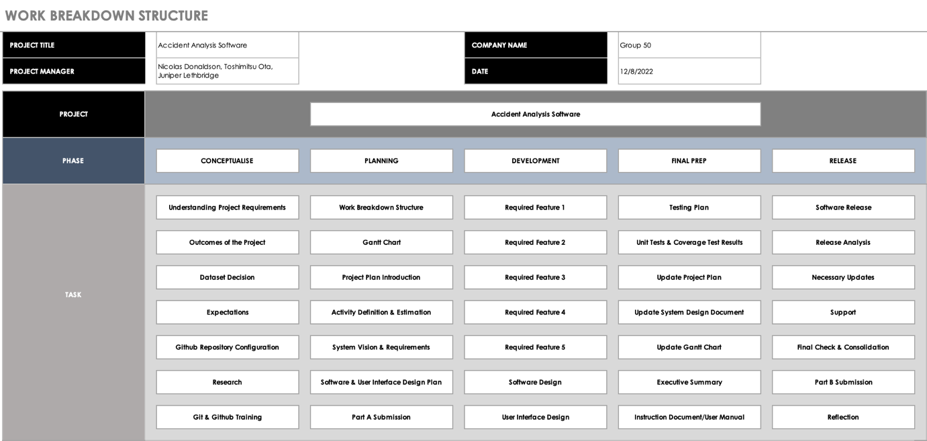

Image: Work Breakdown Structure for Project

*This section should include the work breakdown structure for the whole project. The elements from the WBS should be used to generate your activity definition and those activities should then be scheduled in the Gantt Chart. Remember to consider ALL project activities – anything you do or will need to do should be included in the WBS*

*WBS’s are usually presented as some kind of hierarchical diagram/chart etc. The details what is involved each work unit should be provided in section 3:* ***Activity Definition***

*You do NOT need to do a WBS Dictionary for this project – the activity definition (whilst slightly different) will suffice. The WBS is focussed on SCOPE. The Activity definition is focussed on TIME.*

# Activity Definition & Estimation

*From your WBS, define the activities required for your project. You will revise this document and add more detail for part B as you discover more about the project.*

*Each activity should be clearly identified by a number and should match up to your Gantt chart. You should provide some estimations for the time you think each activity will take. This should make it easy to prepare your Gantt chart.*

# Gantt Chart

*This section should contain your Gantt chart. The items in the Gantt chart should match the activity definition from section 3. You should also submit your Gantt chart file separately.*